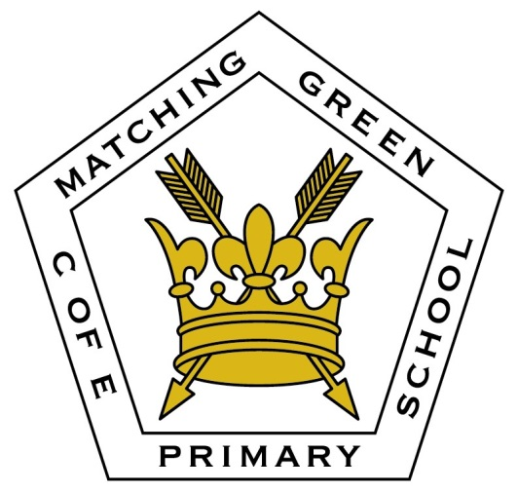
Presentation Policy
(A RECOMMENDED DOCUMENT)
Publish on Website? | NO / YES
Approved by Curriculum Committee on: | 01/10/2020
Staff Consulted: | Teaching Staff  SENCo
Ratified by Governing Body: | 08/10/2020
This policy is linked to and should therefore be read in conjunction with: | English Policy  Curriculum Policies  Handwriting Policy  Homework Policy  Home School Agreement
Review in: | 2 years

Purpose
The purpose of this policy is to ensure a consistently high standard of presentation across the whole school which all children and staff recognise, understand and follow. This policy shares Key Stage One and Key Stage Two guidance and outlines the expectations and progression throughout the school.
Application
These expectations are intended to apply to the vast majority of children in our school. Occasionally a decision will need to be made to personalise the presentation expectations for a child who has such specific needs that these expectations could be a barrier to their progress (e.g. a child with physical difficulties writing).
How it will look at Matching Green C of E Primary School
Staff will ensure that presentation of work is actively taught as it will not ‘just happen’. It should be a main focus at the start of each academic year and then be referred to periodically throughout the year.

Where possible, all staff should ensure that presentation is celebrated through:
- Displaying work with a high standard of presentation
- Celebrating work with a high standard of presentation in whole class situations.
- Ensure good presentation is rewarded in line with whole school behaviour policy (praise, stickers, House Points, Head teacher awards)
- Sharing of good work in whole school assemblies
- Handwriting will be taught in line with the handwriting policy on a regular basis. The focus of these lessons will be correct letter formation and cursive handwriting. Children will need to be taught how to write in a cursive style using the Nelson Thrones handwriting scheme.

Whole School Rules
- All drawings and diagrams should be in pencil.
- Children are only to use pencils, colouring pencils for colouring in or black handwriting pens in exercise books.
- Purple pen will be used by the children for self correction
- Blue or green pen to be used by Teachers and TAs when marking work
- Absolutely no writing on covers or on the inside covers of books.
- No doodling on pages in books or on covers.
- Tippex and correction pens are not to be used.
- Teachers model same high standards in presentation as expected from pupils
- All work is dated by pupils.
- Children are encouraged to use DUMTUM (date, underline, miss a line, title, underline, miss a line).
- All work has a Learning Objective( or in Key Stage One the WALT (We Are Learning To) written as a title
- Anything copied from board is spelled correctly with capital letters in the correct place
- High-frequency words are spelled correctly
- KS1 – the first 100 key words (these will be on display in the classroom)
- KS2 – the first 200 key words (these will be on display in the classroom)
- All Classes - the year group specific words (these will be on display in the classroom)
- Straight lines (e.g. underlining) are drawn with a ruler
- Any worksheets that are given to the pupils are trimmed to fit books
- Worksheets are stuck in carefully (i.e. straight with equally spaced gaps around them)
- Errors are not scribbled out –a neat line is used
- A new page is started for every new piece of work
- Where lines are provided in the book, pupils write on the lines
Maths books
- In maths books, pupils write numerals within the squares.
- In maths books, margins are drawn two whole squares in from the left hand side of the page.
- Question numbers are written inside the margin
- Teachers use their profession judgement regarding the appropriate line and square size in books and will move pupils to smaller squares or narrower lines as they deem appropriate in order to maintain good presentation and sufficient space for the amount of work the pupil produces.
Please see Appendix 1 for specific Key Stage expectations.
Front cover of books
Plain white labels will be used for the front of the books, Nelson Thornes font will be used. The pupils name will go on the first line, underneath that the class name, underneath that the year group and lastly the subject the book is for.
Pupil’s ability groups will be written on a separate label. Ability group labels are expected for english and maths.
Monitoring
Presentation will be monitored by the Senior Leadership Team on a regular basis through:
- Book scrutinies
- Observations
- Pupil Perception Surveys
- Pupil Interviews

Action for teachers to take if presentation is poor

- Where a pupil has deliberately defaced work (scribbled out, doodled on, torn etc), it will be re-written in the pupil's own time.
- Where presentation has slipped a little, a written or verbal reminder of expectation will be given. If this is ignored in future work, it will be re-written in review time if there is enough time. Failing that, the pupil will be asked to re-write it in their own time.

Appendix 1
Exemplars for Key Stage One
English
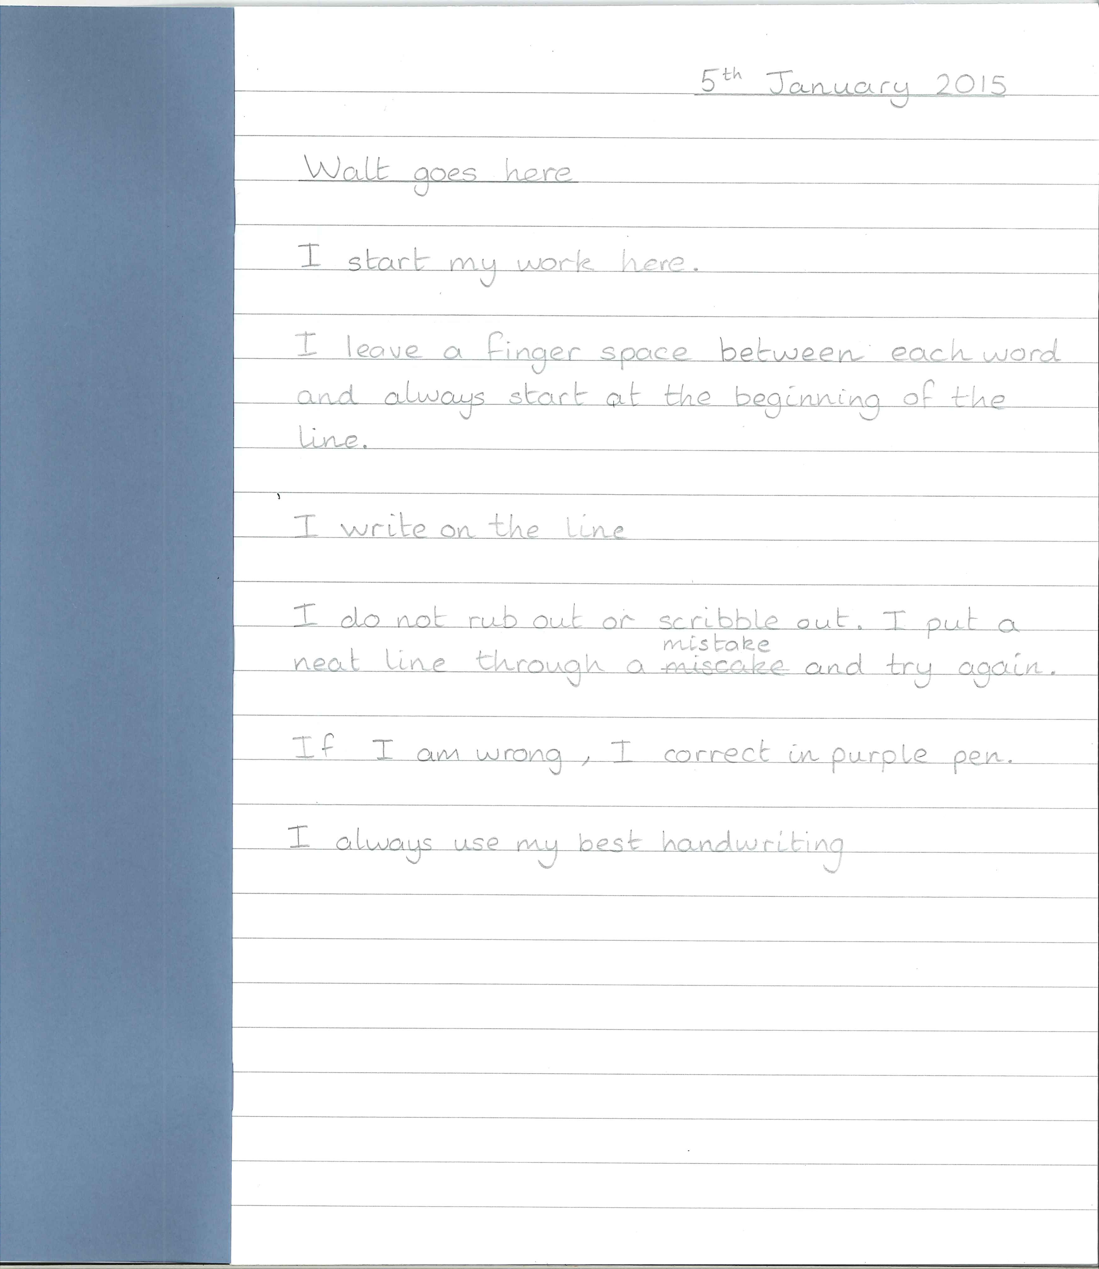

Maths
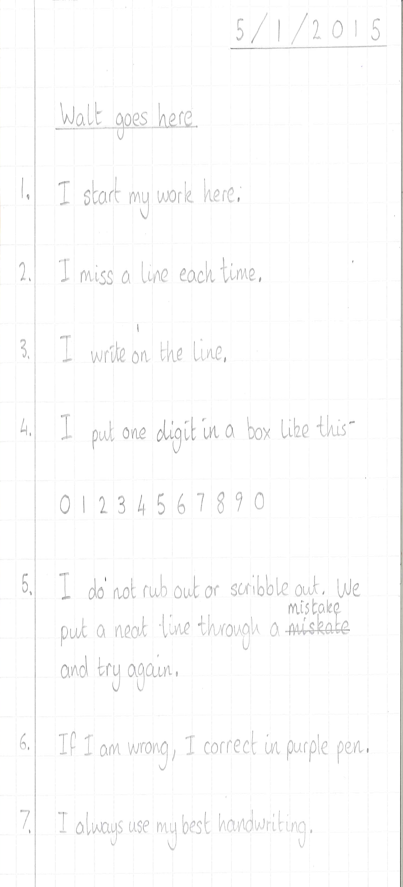

Exemplars for Key Stage Two
English
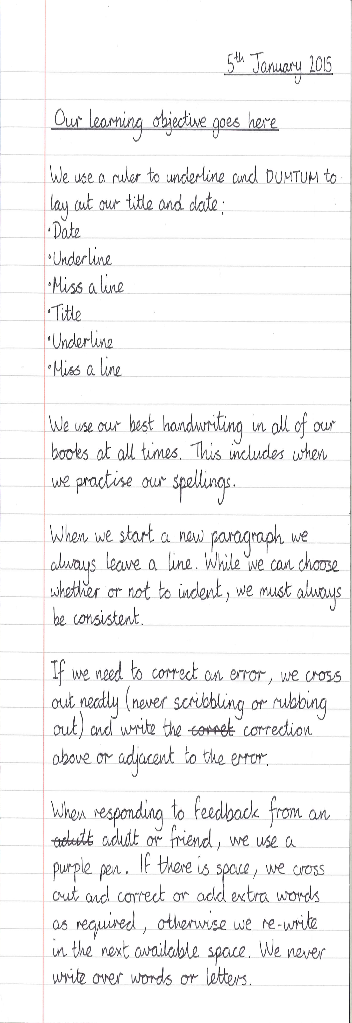

Maths


